We got a x86 PE file.

Throw it into IDA

we get

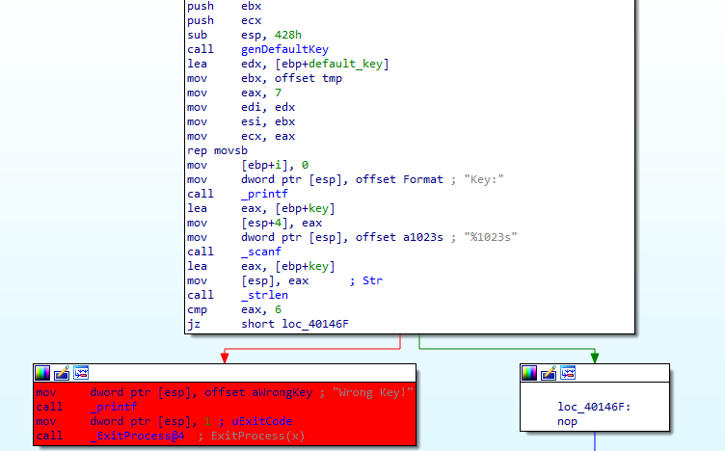

First it generate a default_key

Then initialize i = 0

Then it require enter a Key, which must have length equals to 6

After that it check the key with simple xor byte algorithm

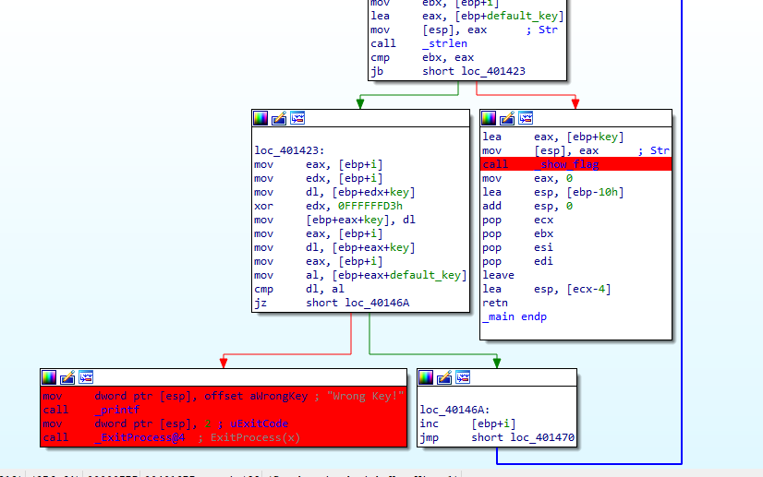

it just xor each byte of key with 0xD3 then compare with this byte with correspond byte in default key

->> get each byte in default_key then xor with 0xD3 you get the key

If it is correct key, you get the FLAG

python Script for key

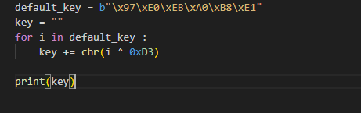

Now you have 2 choices: run app with the key and get the FLAG

Or reverse show_flag function

if you reverse show_flag function

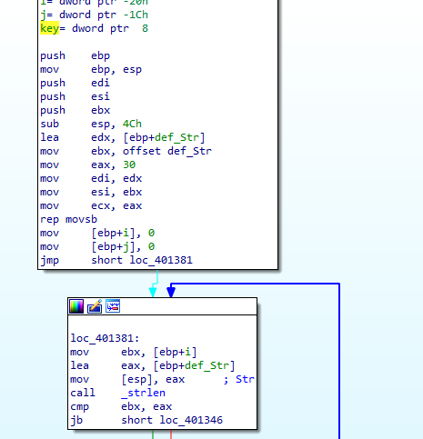

first it have a default String which has length equal to 30

then again xor stub

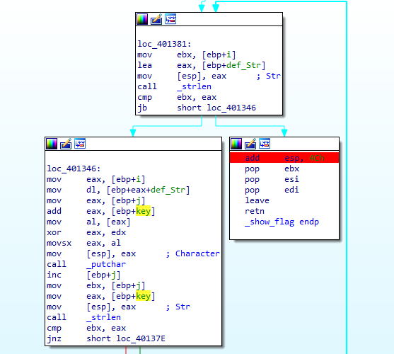

kind of easy for python script

-Because i run the program then get the flag so it can just give you a hint for it:

python way:

for i in range(len(def_Str)):

flag += chr(ord(def_Str[i]) ^ ord(key[i%6]))